

| **Semester: II** | | | | | | |
| --- | --- | --- | --- | --- | --- | --- |
| **CHEMISTRY OF FUNCTIONAL MATERIALS**  **(Category: Professional Core Course) Stream: CS (Theory and Practice)** | | | | | | |
| **Course Code** | **:** | **22CHY22C** |  | **CIE** | **:** | **100 Marks** |
| **Credits: L:T:P** | **:** | **3:0:1** |  | **SEE** | **:** | **100 Marks** |
| **Total Hours** | **:** | **42L+ 30P** |  | **SEE Duration** | **:** | **3 Hours** |

**Unit-II- Nanomaterials and thin film fabrication techniques**

C MANJUNATHA, Ph.D, MRSC

Assistant Professor, Department of Chemistry, RV College of Engineering

Bengaluru-560059, INDIA, Phone: +91 9036651277

E-mail: manjunathac@rvce.edu.in; manju.chem20@gmail.com



**Introduction to Nanomaterials/Science/Technology**

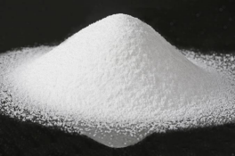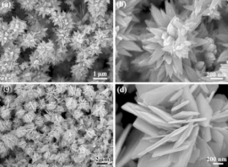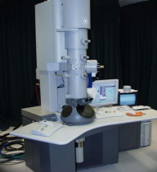❖ **Nanomaterials** are commonly defined as materials with an average grain size less than 100 nanometers.

❖ The word ***"nano***" originates from the Greek word "nanos" which means "dwarf". However, in scientific language it is a prefix which has a value equal to "one billionth, i.e. 10−9.

❖ Therefore, one nanometer is ***one billionth of a meter (1 nm = 10−9 m).***

8/4/2023 Dr. Manjunatha. C, Assistant Professor, Dept. Chemistry, RVCE 2

**Nano-dimension comparison**

1.Diameter of a hydrogen atom is about 0.1 nm. If ten hydrogen atoms are aligned in a line, then the resulting length would be approximately 1 nm. Similarly, 1 nm is approximately 5 silicon atoms aligned in a line. 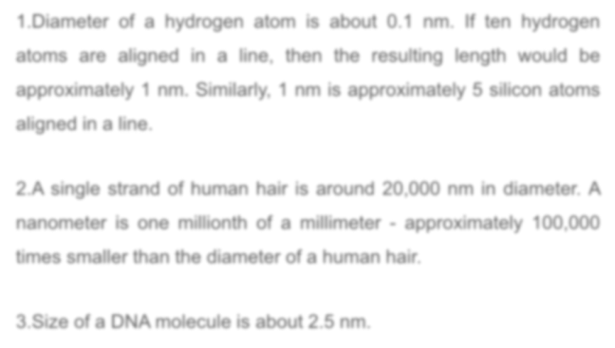

2.A single strand of human hair is around 20,000 nm in diameter. A nanometer is one millionth of a millimeter - approximately 100,000 times smaller than the diameter of a human hair.

3.Size of a DNA molecule is about 2.5 nm.

8/4/2023 Dr. Manjunatha. C, Assistant Professor, Dept. Chemistry, RVCE 3

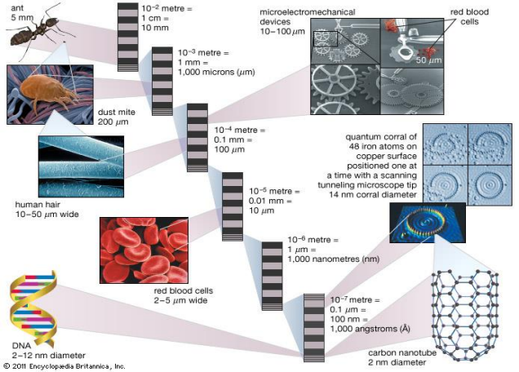

***Nanoscience and Nanotechnology***

Nanostructure science and technology is a broad and interdisciplinary area of research and development activity that has been growing explosively worldwide in the past few years. It has the potential for revolutionizing the ways in which materials and products are created and the range and nature of functionalities that can be accessed. It is already having a significant commercial impact, which will assuredly increase in the future.

“***Nanoscience*** *is the study of phenomena and manipulation of materials at atomic, molecular and macromolecular scales, where properties differ significantly from those at a larger scale”*

***Nanotechnologies*** *are the design, characterization, production and application of structures, devices and systems by controlling shape and size at nanometre scale.*

8/4/2023 Dr. Manjunatha.c, Assistant Professor, Dept. Chemistry, RVCE 5

**Classification of Nanomaterials**

**Nanostructured materials are classified as**

***a) Zero dimensional***: Nanomaterials are less than 100nm in all three dimensions.

***b) One dimensional***: Nanomaterials are less than 100nm in any two dimensions.

***c) Two dimensional***: Nanomaterials are less than 100nm in any one dimensions, and

***d) Three dimensional nanostructures***: Nanomaterials are aggregations of any of the above (0, 1, 2D) dimensional nanomaterial with greater than 100nm in all the three dimensions.

8/4/2023 Dr. Manjunatha.c, Assistant Professor, Dept. Chemistry, RVCE 6

8/4/2023 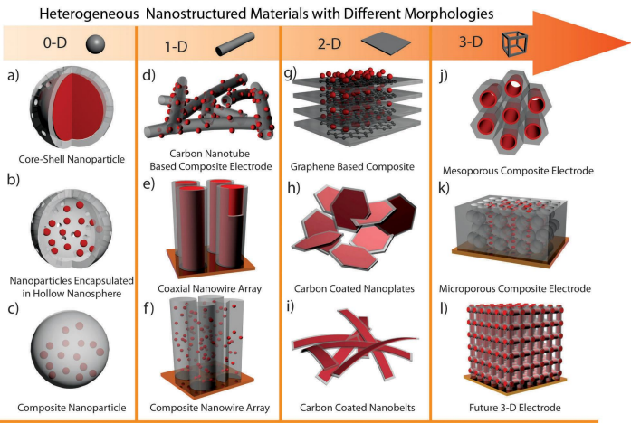Dr. Manjunatha.c, Assistant Professor, Dept. Chemistry, RVCE 7

***Properties of Nanomaterials in comparison to bulk: Surface area, Optical, Catalytic properties***

**Properties of Nanomaterials**

Nanomaterials have the structural features in between of those ***of atoms and the bulk materials.*** The properties of materials with nanometer dimensions are significantly different from those of atoms and bulks materials. This is mainly due to the nanometer size of the materials which render them:

***(i) large fraction of surface atoms***;

***(ii) high surface energy***;

***(iii) spatial confinement***;

***(iv) reduced imperfections***,

which do not exist in the corresponding bulk materials.

8/4/2023 Dr. Manjunatha.c, Assistant Professor, Dept. Chemistry, RVCE 8

***Surface area of Nanomaterials and bulk materials***

❑ When particles are created with dimensions of about 1–100 nanometers (where the particles can be “seen” only with powerful specialized microscopes), the materials’ properties change significantly from those at larger scales.

❑ Properties such as **Optical**, **electrical, magnetic, and chemical reactivity** change as a function of the size of the particle. ❑Nanoscale materials have far **larger surface area**s than similar masses of larger-scale materials. As surface area per mass of a material increases, a ***greater amount of the material can come into contact with surrounding materials, thus affecting reactivity.***

8/4/2023 Dr. Manjunatha.c, Assistant Professor, Dept. Chemistry, RVCE 9

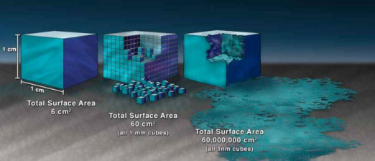

8/4/2023 Dr. Manjunatha.c, Assistant Professor, Dept. Chemistry, RVCE 10

**Band gap of nanomaterial increases with decrease in the size**

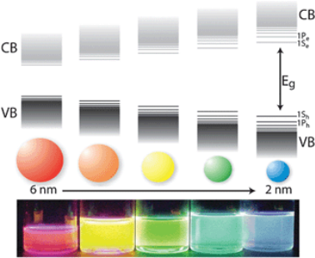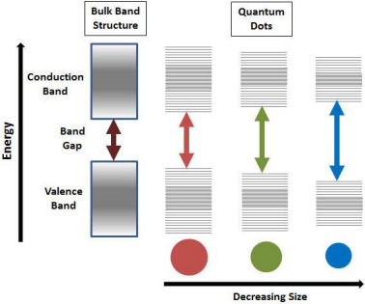8/4/2023 Dr. Manjunatha.c, Assistant Professor, Dept. Chemistry, RVCE 11

***Optical Properties of Nanomaterials***

One of the most fascinating and useful aspects of nanomaterial is their ***optical properties.***

*The change in optical properties is mainly due to the surface plasmon resonance and the increased energy level spacing.*

***Surface Plasmon Resonance (SPR): The coherent excitation of entire free electrons in the conduction band may produce an in-phase oscillation with incident visible light, called surface Plasmon resonance.*** *When the size of a metal nanocrystal is smaller than the wavelength of incident radiation, a surface plasmon resonance is generated. Thus, plasmon resonance depends* ***on the particle size****.*

***In solid state physics****, the plasmon represents the* ***collective oscillation of a free charge in a metal****, and may be considered as a kind of* ***plasma wave****. The positive electrical charge in the metal* ***is fixed*** *and the free electron* ***is free to move*** *around it. An applied external electric field, as from a light source, causes the free electrons at the surface of the* ***metal to vibrate collectively****, giving rise to surface plasmons.*

8/4/2023 Dr. Manjunatha.c, Assistant Professor, Dept. Chemistry, RVCE 12



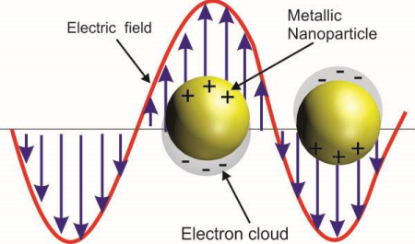

8/4/2023 Dr. Manjunatha.c, Assistant Professor, Dept. Chemistry, RVCE 13

•*“Since electrons are also* ***particles with an electric charge****, when they vibrate they also* ***generate an electric field****, and when the electric field from the vibration of free electrons and the applied external electric field (e.g., electromagnetic waves) resonate the resulting phenomenon is referred to as a* ***surface plasmon resonance”*** *that takes place at the surface of the metal.*

• *However, if light irradiates a solution that contains dispersed metal nanoparticles smaller than the wavelength of light, then depending on the electric field of light, the deviation produces a free electron at the surface of the metal. As a result, the weak or thick portions of the electric field appear on the nanoparticle surface and can be considered as a kind of polarization.*

8/4/2023 Dr. Manjunatha.c, Assistant Professor, Dept. Chemistry, RVCE 14

• Nanoparticles absorb visible light and produce surface plasmons. • Small nanoparticles absorb blue-green wavelength of light, but they reflect red light.

• When size of the nanoparticles increases, wavelength of plasmon resonance absorption moves to longer wavelength (red wavelength) side. Now red light is absorbed and blue light is reflected, resulting in pale blue or purple colour for the particles.

• When particle size increase towards critical limit, SPR wavelength shifts to the IR spectrum of the radiation and visible lights are reflected. ***These properties find potential applications in biosensors***.

It should be noted that, metal nanorods exhibit two SPR modes, one due to **transverse** and the other due to **longitudinal** excitations. The wavelength of transverse mode is usually set at nearly **520 nm for gold and 410 nm for silver**. However, their longitudinal modes can be tuned to span from **visible region to near IR region** by controlling their aspect ratios.

8/4/2023 Dr. Manjunatha.c, Assistant Professor, Dept. Chemistry, RVCE 15

*The wavelength corresponding to the SPR depends on the* ***kind of metal****, the* ***shape of the metal nanoparticle,*** *and the* ***extent of aggregation of the metallic nanoparticles****.*

❖ *For example, the wavelength of the SPR band maximum of a spherical* ***Au nanoparticle is 520–550 nm****. If a colloidal Au nanoparticle solution is now irradiated with visible light at these wavelengths (520–550 nm), the visible light corresponding to the* ***green color*** *is absorbed and the particles now display a* ***red purple*** *color, which is the* ***complementary color to green****.*

❖ *In a colloidal* ***Ag nanoparticle*** *solution which has a SPR band maximum near* ***400 nm****, the* ***blue color*** *of the visible light is absorbed and the Ag nanoparticles now take on* ***a yellow color****, the complementary color to blue.*

8/4/2023 Dr. Manjunatha.c, Assistant Professor, Dept. Chemistry, RVCE 16

8/4/2023 Dr. Manjunatha.c, Assistant Professor, Dept. Chemistry, RVCE 17

8/4/2023 Dr. Manjunatha.c, Assistant Professor, Dept. Chemistry, RVCE 18

***Catalytic Properties of Nanomaterials***

• The rate of any chemical reaction depends on the number of active reaction sites on the catalyst.

• The surface area of nanoscaled catalyst is larger than that of bulk material.

• As compared to bulk catalyst, the nanoscale catalyst of same material with same quantity has more number of active sites.

• Because of unsaturated valencies of surface atoms of Nanoparticle catalyst, they catalyze the reactions at much faster rates due to higher surface energies as compared to their respective bulk partners.

• Therefore, the nanoscaled material is found to exhibit very high catalytic efficiency than the corresponding bulk material.

8/4/2023 Dr. Manjunatha.c, Assistant Professor, Dept. Chemistry, RVCE 19

**Hydroformylation of 1–Hexene over Rh/Nano -oxide**

****• The highest activity with 100% total conversion and 96% yield of aldehydes

was obtained with the **Rh/nano-ZnO catalyst.**

• The **Rh/nano-ZnO catalyst** was found to be more stable and active than the corresponding rhodium catalyst supported on **bulk ZnO (76% yield).**

****8/4/2023 Dr. Manjunatha.c, Assistant Professor, Dept. Chemistry, RVCE 20

Catalytic hydrogenation of p-nitrophenol to p-aminophenol using nano-sized nickel

(a) Nano-sized nickel and 

(b) Raney Ni

The hydrogenation rate of nano-sized nickel

is about 15 times higher than that of Raney

Ni at similar reaction conditions

The **nano-sized nickel** system suffers 54%

deactivation, while the **Raney nickel** system

suffers 80.4% deactivation only throughout 

six continuous hydrogenation cycles.

These results indicate that the catalytic

stability of **nano-sized nickel** system is

superior to that of the **Raney nickel system**

8/4/2023 Dr. Manjunatha.c, Assistant Professor, Dept. Chemistry, RVCE 21

**Synthesis of Nanomaterials**: SCS for metal oxide, Sol-Gel- for TiO2 nanoparticles Carbon Nano materials

Researchers are active worldwide developing new preparation methods for functionally and technologically useful nanoparticles and nanostructures. Nature efficiently builds nanostructures by relying on chemical approaches. There are many methods developed to prepare nanomaterials, they are listed as chemical methods (bottom up) and physical methods (top down) as shown in Table.1

**Table. 1** General methods of synthesis of nanomaterials

**CHEMICAL METHODS** (Bottom Up) **PHYSICAL METHODS** (Top down) **Combustion Synthesis** Inert gas condensation

Hydrothermal Sputtering

**Sol-gel method** Molecular beam epitaxy

Micelles micro emulsion Lithography

Single crystal growth Ion beam technique

Colloidal methods Chemical vapor deposition

8/4/2023 Dr. Manjunatha.c, Assistant Professor, Dept. Chemistry, RVCE 22

8/4/2023 Dr. Manjunatha.c, Assistant Professor, Dept. Chemistry, RVCE 23

***1) Low temperature solution combustion (SCS) method*** This method was discovered by ***Prof. K. C. Patil*** when the mixture of Al(NO3)3·9H2O and urea solution, rapidly heated around 500 ºC in a muffle furnace. The author observed that the solution mixture undergoes vaporization followed by vigorous ignition with an incandescent flame yielding voluminous white product which was identified as *α*-Al2O3.

**Combustion method:** is a low temperature, time saving, energy efficient, self propagating method, involving **spontaneous exothermic redox reaction** between **metal nitrate and organic fuel**, used to prepare nanomaterials.

**Principle:** The method is based on the utilization of heat energy produced during the exothermic spontaneous redox reaction between an oxidizer (metal nitrate) and a reducing agent (organic fuel). The oxidizer can be of any metal nitrates and reducing agents may be organic fuels, such as glycine, oxalic acid, urea, hexamine, sugar, EDTA, Dextrose etc.

**Metal nitrate + Fuel nano Metal oxide + Gases**

8/4/2023 Dr. Manjunatha.c, Assistant Professor, Dept. Chemistry, RVCE 24

The amount of fuel can be calculated in such way that the total oxidizing valency of fuel should match with the total reducing valency of metal nitrate. The following formula can be used to calculate the amount of fuel:

Mol. Wt. of fuelx Valency of fuel **=**x Valency of metal nitrate Wt. of metal nitrate

Wt. of fuel

Mol. Wt. of metal nitrate

For the calculation of valency of fuel and metal nitrate, the valency to be considered for the elements such as of N, O, H, C, and Mn+ are 0, -2, +1, +4 and +n respectively.

**Procedure:**

**Step1: Weighing and mixing of the reactants**

Weighing of all the reactants (metal nitrate and a fuel) according to stoichiometry, by using the above formula and dissolved in 

minimum quantity of distilled water in a beaker of suitable size.

**The mixture is stirred on a magnetic stirrer till to get uniform solution as shown in figure (left side).**

Magnetic stirrer on which uniform redox solution is obtained by stirring

8/4/2023 Dr. Manjunatha.c, Assistant Professor, Dept. Chemistry, RVCE 25

***Step 2: Evaporation and combustion***

The uniformly mixed 

solution is kept in a

furnace maintained

at 500 ºC

Spontaneous/vigoro 

us combustion

occurs and

propagates

throughout the

redox mixture

Evaporation (boiling) of water 

Final nano 

powder of

corresponding metal oxide

8/4/2023 Dr. Manjunatha.c, Assistant Professor, Dept. Chemistry, RVCE 26

❖The clear solution is kept in a furnace (shown below) maintained at 500 ºC.

❖Firstly the solution undergoes evaporation that results in more concentrated, uniformly mixed viscous-gel type substance. ❖After some time, the viscous-gel catches fire and propagates spontaneously in the redox mixture in the form of either a flame type or smouldering type.

❖The combustion lasts for about 1-2 min.

❖During the flame propagation large quantity of gasses and high temperature produced helps in the formation of respective nano metal oxide.

❖The SCS has emerged as a viable technique for the preparation of advanced nano-metal oxide.

8/4/2023 Dr. Manjunatha.c, Assistant Professor, Dept. Chemistry, RVCE 27

The **most important advantages of SCS process are:** ✓It is an easy and fast process that uses relatively simple equipment. ✓High-purity products can be easily prepared by using this method. ✓Composition, structure, homogeneity, size and stoichiometry of the products can be controlled.

✓High exothermicity of the metal nitrate–fuel reaction permits incorporation of desired quantity of dopants in the various hosts of industrially useful phosphors.

✓This is the cheap method as compared to conventional solid state method

8/4/2023 Dr. Manjunatha.c, Assistant Professor, Dept. Chemistry, RVCE 28

Stoichiometry calculation



**Valency calculation**

Zn(NO₃)₂•6H₂OZn2+ 2N 6O 6H2O **Total Valency**

| (Zinc Nitrate)  297 g/mol | +2 | 2x0=0 | 6x(-2)=-12 | 6x0=0 | **-10** |
| --- | --- | --- | --- | --- | --- |
| Al(NO₃)₃·9H₂O  (Aluminium nitrate) **375.14** g/mol | A3+ | 3N | 9O | 9H2O |  |
| +3 | 3x0=0 | 9x(-2)=-18 | 9x0=0 | **-15** |
| C6H12O6  (Glucose, )  180.156 g/mol | 6C | 12H | 6O | |  |
| 6x(+4)=+24 | 12x(+1)=+12 | 6(-2)=-12 | | **+24** |
| NH₂‐CH₂‐COOH  (Glycine)  75.07 g/mol | N | 2O | 5H | 2C |  |
| 1x0=0 | 2x(-2)=-4 | 5x(+1)=+5 | 2x(+4)=+8 | **+9** |

8/4/2023 Dr. Manjunatha.c, Assistant Professor, Dept. Chemistry, RVCE 29

**Calculate the amount of glycine fuel required to**

**prepare nano ZnO using**

**8g of hydrated Zinc nitrate (Mol. Mass =297g/mol)**

**[(Wt x Valency)/Mol Mass ] of Glycine = [(Wt x Valency)/Mol Mass ] of Zinc nitrate [(Wt x 9)/75.07] of glycine = [(8x10)/297]**

**Wt of glycine =…………….. g**

8/4/2023 Dr. Manjunatha.c, Assistant Professor, Dept. Chemistry, RVCE 30

***2. Sol-gel method***

It is a wet chemical technique widely used for the fabrication of nano structured ceramic materials and thin films.

*Sol-gel process involves the conversion of precursor solution (usually metal salts or metal alkoxide) into a nano-structured inorganic solid through inorganic polymerization reactions catalyzed by water.*

In general, metal alkoxides (M-OR) are widely used as precursors, because they readily react with water.

The reactions involved in the sol-gel process are

1*) Hydrolysis*

M-OR + H2O Ethanol M-OH + ROH Metal alkoxide Metal hydroxide 2) Condensation

M-OR + H O-M M-O-M + R-OH

Condensation…… Condensation ……….. Condensation ………of …..M O-M results in to a polymer network in all the possible directions.

8/4/2023 Dr. Manjunatha.c, Assistant Professor, Dept. Chemistry, RVCE 31

**Process:**

***Step 1:*** Preparation of homogeneous solution either by dissolution of metal salt in water or metal alkoxide in an organic solvent (usually alcohol) that is miscible in water.

***Step 2: ‘Sol’ formation by hydrolysis:*** It involves the conversion of homogeneous solution into a “sol”. (A stable dispersion of colloidal particles of precursors in a solvent is known as sol) due to hydrolysis reaction. During hydrolysis, the alkoxide groups (-OR) are replaced via the nucleophilic attack of the oxygen atom of a water molecules, results in release of alcohol and formation of metal hydroxide (sol).

***Step 3: ‘Gel’ formation by condensation***

The colloidal solution is kept for aging. During aging condensation reaction between two metal hydroxyl/alkoxy species leads to M-O-M bonds with the release of H2O/R-OH. This condensation process continues and finally results in a “gel”, an interconnected, a rigid and porous inorganic network covered completely with liquid phase. This transformation is called **Sol-Gel transition.**

***Step 4: Drying of gel:***

It involves removal of liquid phase from gel network. There are different ways of drying gel: •If the gel medium is dried, by removing the liquid solvent (under hyper critical conditions) without destroying the gel network, **“aerogel” is** produced.

• If the solvent is dehydrated by under ambient conditions (removal of R-OH groups), **“xerogel”** are produced.

•If the gel network is sintered at high temperature (800ºC), densification, decomposition of gel results in complete collapse of gel net into powder.

8/4/2023 Dr. Manjunatha.c, Assistant Professor, Dept. Chemistry, RVCE 32

**undisturbed gel network**

**Vigorous Stirring Supercritical**

**Homogeneous aqueous**

**solution of metal**

**salt/alkoxide (in alcohol)**

**Formation of sol**

**(colloidal particles)**

**due to hydrolysis**

**reaction**

**Formation of Gel**

**(inorganic polymer**

**network) due to**

**condensations**

**reactions**

**covered with**

**drying Drying at ambient**

**only airSintering at 800 ºC condition**

**Aerogel Xerogel Powder**

8/4/2023 Dr. Manjunatha.c, Assistant Professor, Dept. Chemistry, RVCE 33

***Example: Preparation of TiO2 by Sol-gel method:* Chemicals required:** Titanium isopropoxide [Ti(O(CH(CH3)2)4], absolute alcohol, distilled water, HNO3

**Equipments/glassware:**

• 250 ml glass beaker, magnetic stirrer, Furnace, oven.

***Procedure:*** Stoichiometric quantity of titanium (IV) isopropoxide is dissolved in absolute ethanol and distilled water in the ratio of Ti:H2O=1:4. HNO3is added to adjust pH and restrain the hydrolysis process of the solution.

•The solution is vigorously stirred for 30 min in order to form sol (a suspension of colloidal particle).

•The sol is kept for aging for about 24 h. During aging sol is transformed into gel. (It is due to polycondensation and formation of inorganic network).

•In order to obtain TiO2nanoparticles, the gels are dried at 120 ºC for 2 h to evaporate water and organic solvent. Then the dry gel is sintered at 450 ºC for 2 h to obtain TiO2nanoparticles.

8/4/2023 Dr. Manjunatha.c, Assistant Professor, Dept. Chemistry, RVCE 34

***Reaction mechanism****: Nucleophilic (H2O) attack on alkoxy group.*

(1)

O

Ti

O O

H O

H

Hydrolysi s

O

Ti

+

H O

OOH

O

O

Isopropanol

B

(2)

Titanium

isopropoxide A

H O

H O

B +

H2O

Ti

O

O

OH

H

H

D E

Ti

O O O

H

C

F

8/4/2023 Dr. Manjunatha.c, Assistant Professor, Dept. Chemistry, RVCE 35

O

H O

H O

O

Ti

O O O

Ti

O O O

H

H

O

H O

O

Ti

Ti Ti

Ti

Ti

Ti

Ti

O O

O O

O O

O O O

O

O

O O O

O

O

O

Ti

O O O

Ti

O O O

O

Ti

O O O

O

O

O

8/4/2023 Dr. Manjunatha.c, Assistant Professor, Dept. Chemistry, RVCE 36

**The advantages of this technique are evident.**

❖It is a simple and economic technique, as the fabrication does not need expansive machinery or apparatuses.

❖It offers a high flexibility as one can produce materials with a wide range of stoichiometry and additional dopants.

❖It allows the fabrication of high quality coatings.

❖The starting materials are easily to obtain, not expensive and available in a high purity.

❖Nanomaterials of variety of shapes can be prepared.

8/4/2023 Dr. Manjunatha.c, Assistant Professor, Dept. Chemistry, RVCE 37

**Carbon nanotubes**



Carbon is an incredibly versatile element. Depending on how atoms are arranged, it can produce hard diamonds or soft graphite. Carbon materials can exist in various dimensions. The fig below clearly shows the various forms of carbon materials.

8/4/2023 Dr. Manjunatha.c, Assistant Professor, Dept. Chemistry, RVCE 38



8/4/2023 Dr. Manjunatha.c, Assistant Professor, Dept. Chemistry, RVCE 39



**Carbon nanotubes**

In 1970, ***Morinobu Endo***, First carbon filaments of nanometer dimensions was prepared, as part of his PhD studies at the University of Orleans in France. He grew carbon fibers about 7 nm in diameter using ***a vapor growth technique***. Filaments were not recognized as nanotubes and were not studied.

*In 1991, while experimenting on fullerene and looking into soot residues* ***Sumio LIJIMA*** *invented two types of nanotubes namely single walled carbon nanotubes (SWNTs) and multi walled carbon nanotubes (MWNTs). SWNT consists only of a single graphene sheet with one atomic layer in thickness, while MWNT is formed from 2 to several tens of graphene sheets arranged concentrically into tube structures.*

**Definition:**

***Carbon nanotubes*** are a new form of a hexagonal network of carbon atoms rolled up in the form of cylindrical shape.

8/4/2023 Dr. Manjunatha.c, Assistant Professor, Dept. Chemistry, RVCE 40



8/4/2023 Dr. Manjunatha.c, Assistant Professor, Dept. Chemistry, RVCE 41



**Graphene and Carbon nanotubes**

****8/4/2023 Dr. Manjunatha.c, Assistant Professor, Dept. Chemistry, RVCE 42



Different forms : (**Types of CNTs)**

**1) Single-Wall Nanotube (SWNT) (a. Arm Chair, b. Chiral c. Zig-Zag )**

**2) Multi-Walled Nanotubes (MWNT)** Multiple rolled layers of graphene sheets, More resistant to chemical changes than SWNTs

8/4/2023 Dr. Manjunatha.c, Assistant Professor, Dept. Chemistry, RVCE 43



8/4/2023 Dr. Manjunatha.c, Assistant Professor, Dept. Chemistry, RVCE 44

**Synthesis of CNTs by modified CVD method:**

Chemical Vapor Deposition: Requirements**:** ● High Temperature Tubular furnace (500 to 1500 ℃)

● Source of Carbon: Methane, ethylene, hydrocarbon gas, xylene, natural gas ● Substrate: carbon, quartz, silicon ● Inert gas: Argon, Hydrogen, Nitrogen ● Catalyst: Ferrocene, Nickellocene, Cobaltocene

Zaytseva, O., Neumann, G. Carbon nanomaterials: production, impact on plant development, agricultural and

environmental applications. *Chem. Biol. Technol. Agric.* **3**, 17 (2016). https://doi.org/10.1186/s40538-016-0070-8

8/4/2023 Dr. Manjunatha.c, Assistant Professor, Dept. Chemistry, RVCE 45



**Steps:** Procedure involves as follows

❖ The cleaned quartz/carbon/silica substrate is placed in the middle of the tubular furnace.

❖ In order to maintain the inert atmosphere inside the furnace, initially the air/oxygen present inside the tubular furnace has to be removed by passing the argon or nitrogen gas for about 30 min.

❖ After maintain the inert gas atmosphere, the required temperature is set with slow heating rate. ❖ The hydrocarbon precursors in gaseous forms along with ferrocene and Benzene/toluene vapors are pumped into the reaction chamber.

❖ The furnace is heated up to 850–1000 °C and 550–700 °C for SWCNT and MWCNT production respectively. ❖ Initially, at high temperature, due the thermal decomposition of hydrocarbon, carbon atoms are formed are dissolved in the metal nanoparticle catalyst.

❖ Once the threshold concentration of carbon in the catalyst reached, a semi fullerene cap type of structure is formed due to precipitation of carbon atoms. This acts as a seed for further crystal growth, which further continues to grow in tubular form results in to CNT.

❖ After the formation of CNT on catalyst is completed as shown in the above figure, the supply of the reactant/catalyst varpors are stopped.

❖ Then the furnace temperature is reduced slowly to room temperature and supply of the inert gas also stopped. ❖ The CNT formed on catalyst is taken out along with the substrate, subjected to purification.

Zaytseva, O., Neumann, G. Carbon nanomaterials: production, impact on plant development, agricultural and

environmental applications. *Chem. Biol. Technol. Agric.* **3**, 17 (2016). https://doi.org/10.1186/s40538-016-0070-8

8/4/2023 Dr. Manjunatha.c, Assistant Professor, Dept. Chemistry, RVCE 46



**CNT growth mechanism in CVD**



8/4/2023 Dr. Manjunatha.c, Assistant Professor, Dept. Chemistry, RVCE 47



8/4/2023 Dr. Manjunatha.c, Assistant Professor, Dept. Chemistry, RVCE 48



8/4/2023 Dr. Manjunatha.c, Assistant Professor, Dept. Chemistry, RVCE 49



Synthesis of Large Arrays of Well-Aligned Carbon Nanotubes on Glass, Z. F. RenZ. P. HuangJ. W. XuJ. H. WangP. BushM. P. Siegaland P. N. Provencio , Science

6 Nov 1998, Vol 282, Issue 5391

pp. 1105-1107

DOI: 10.1126/science.282.5391.1105

8/4/2023 Dr. Manjunatha.c, Assistant Professor, Dept. Chemistry, RVCE 50



***Importance of CVD:***

❑ The three main parameters for CNT growth in CVD are the atmosphere, carbon source, catalyst, and growth temperature.

❑ Low-temperature (600–900°C) yields MWNTs, whereas a higher temperature (900–1,200°C) reaction favors SWNTs growth.

❑ The most commonly used catalysts for CNT growth are the transition metals (Fe,

Co, Ni) from carbon sources like organometallocenes (ferrocene, cobaltocene, nickelocene), nitrates and others.

❑ A correlation was found between the size of catalyst particles and the nanotube diameter. Hence, metal nanoparticles of controlled size can be used to grow CNTs of controlled diameter.

❑The CVD method allows CNT growth in a variety of forms, *such as powder, thin or thick films, aligned or entangled, straight or coiled, or even a desired architecture of nanotubes at predefined sites on a patterned substrate.*

❑ It also offers better control over growth parameters in comparison to other synthesis methods.

8/4/2023 Dr. Manjunatha.c, Assistant Professor, Dept. Chemistry, RVCE 51



8/4/2023 Dr. Manjunatha.c, Assistant Professor, Dept. Chemistry, RVCE 52



***Functionalization of Carbon Nanotubes***

Despite CNTs’s exceptional properties, there are two main limitations that hinder its use. The surface energy of CNTs is significantly different from that of matrices such as common organic solvents or polymers and ***CNTs may not have chemical affinity to the organic matrices*** and thus, the dispersion of CNTs into matrices is the biggest obstacle in practice.

The modification/ functionalization of CNTs with other materials, makes it the most attractive and ultimate candidate for a many applications which includes nanodevices, to organic electronics. The modification/ functionalization of CNTs can be simply divided into a) Chemical (covalent) and b) Physical (noncovalent) functionalization

**Chemical functionalization** is based on the covalent bond of functional groups onto carbon form of CNTs. It can be performed at the end caps of nanotubes or at their sidewalls which have many defects. Direct covalent sidewall functionalization is associated with a change of hybridization from *sp2 to sp3 and a simultaneous loss of p-conjugation system.*

8/4/2023 Dr. Manjunatha.c, Assistant Professor, Dept. Chemistry, RVCE 53



8/4/2023 Dr. Manjunatha.c, Assistant Professor, Dept. Chemistry, RVCE 54



8/4/2023 Dr. Manjunatha.c, Assistant Professor, Dept. Chemistry, RVCE 55

8/4/2023 Dr. Manjunatha.c, Assistant Professor, Dept. Chemistry, RVCE 56



**b) Non-covalent functionalization: I**t **does not destroy the conjugated system** of the CNTs sidewalls, and therefore it does not affect the final structural properties of the material. The CNTs are functionalized non-covalently by **aromatic compounds**, **surfactants, and polymers,** employing ***π-π stacking or hydrophobic interactions*** for the most part. In this approaches, the non-covalent modifications of CNTs can do much to preserve their desired properties, while improving their solubilities quite remarkably. (Ex: aromatic small molecule absorption, polymer wrapping, surfactants, biopolymers)

8/4/2023 Dr. Manjunatha.c, Assistant Professor, Dept. Chemistry, RVCE 57



Properties of CNTs:

❑Carbon-carbon bonds are one of the strongest bond in nature, **Composed entirely of sp2 bonds**

❑132,000,000:1 Length-To-Diameter Ratio

❑ Diameter of 3 to 9 nm

❑ Lengths in the millimeter range

❑ Extremely high Young’s modulus

❑ Nanotubes can be either **electrically conductive or semi conductive**, depending on their **helicity.**

❑ These one-dimensional fibers exhibit **electrical conductivity as high as copper, thermal conductivity as high as diamond.**

❑ Strength 100 times greater than steel at one sixth the weight, and high strain to failure. ❑ Can act as both thermal conductors and thermal insulators.

8/4/2023 Dr. Manjunatha.c, Assistant Professor, Dept. Chemistry, RVCE 58



**Selected electrical and mechanical properties of carbon nanotubes**

| **Properties**  Thermal conductivity (W/mK) | **CNTs**  >3000 | **Other materials**  Copper= 400  Carbon fiber (pitch)=1000 Carbon fiber (PAN)=8-105 |
| --- | --- | --- |
| Electrical conductivity (S/m) | 106-107 | Copper=6x106  Carbon fiber (pitch)=2-8.5x106 Carbon fiber (PAN)=6.5-14x106 |
| Young’s modulus (Tpa) | 1-5 | Steel=0.18-0.2  Kevlar=0.06-0.18  Diamond= 0.1-0.12 |
| Tensile strength (Gpa) | 15-150 | Steel=0.38-1.55  Kevlar=3.6-3.8 |

8/4/2023 Dr. Manjunatha.c, Assistant Professor, Dept. Chemistry, RVCE 59



8/4/2023 Dr. Manjunatha.c, Assistant Professor, Dept. Chemistry, RVCE 60



**Applications of CNTs:**

• Sensor, RFIDs,

• Optoelectronic devices (Field Emission Display ( FED))

• As electrodes in batteries, capacitors and super capacitor electrodes. • As electrode catalyst supports in Polymer Electrolyte Membrane (PEM) fuel cells • Hydrogen Storage material in hydrogen fuel car.

• As electrically powered artificial muscles.

• Elctrocatalyst for water splitting, H2 production.

• Adsorbent and photocatalyst for organic pollutants degradation. • Sensor for heavy metal ion, gases, volatile organic compounds and biomolecules. • Drug carriers

8/4/2023 Dr. Manjunatha.c, Assistant Professor, Dept. Chemistry, RVCE 61

https://doi.org/10.1088/2399-1984/ab5f20

8/4/2023 Dr. Manjunatha.c, Assistant Professor, Dept. Chemistry, RVCE 62



https://doi.org/10.3390/s18061958

8/4/2023 Dr. Manjunatha.c, Assistant Professor, Dept. Chemistry, RVCE 63

8/4/2023 Dr. Manjunatha.c, Assistant Professor, Dept. Chemistry, RVCE 64



**Graphene**: ***The perfect atomic lattice in single sheet.***

***The carbon nanomaterial having only surface.***

• Graphene, an excellent electronic material, discovered in 2004 by **A. K. Geim** and **K. S. Novoselov**, and received Nobel prize in chemistry for this discovery in 2010.

• It has enormous potential in the electronic device community, for example, field-effect transistor, transparent electrode, etc.

Graphene is an allotrope of carbon made of a single layer of carbon atoms that are bonded together in a repeating pattern of hexagons.

❑ It is one million times thinner than paper;

❑ It is also the basic structural element of other allotropes, including charcoal, carbon nanotubes and fullerenes.

❑ Spherical carbon nanomaterials are referred to as *fullerenes*, while cylindrical ones are called *carbon nanotubes*.

❑ SWCNT contains one graphene sheet that rolls up to form a cylinder. MWCNT consist of several graphene sheets rolled up together to form concentric cylinders with large annular space at centre.

8/4/2023 Dr. Manjunatha.c, Assistant Professor, Dept. Chemistry, RVCE 65



**Synthesis of Graphene** 

**Oxide and Reduced**

**Graphene Oxide (rGO)**

**Modified Hummer’s**

**Method**

8/4/2023 Dr. Manjunatha.c, Assistant Professor, Dept. Chemistry, RVCE 66



**Synthesis of Graphene** 

**Oxide and Reduced**

**Graphene Oxide (rGO)**

**Modified Hummer’s**

**Method**

8/4/2023 Dr. Manjunatha.c, Assistant Professor, Dept. Chemistry, RVCE 67



**Stage-I: Synthesis of GO (graphene oxide) from graphite powder**



8/4/2023 Dr. Manjunatha.c, Assistant Professor, Dept. Chemistry, RVCE 68



**Stage-II: Synthesis of Graphene from GO (graphene oxide)**



8/4/2023 Dr. Manjunatha.c, Assistant Professor, Dept. Chemistry, RVCE 69

***Functionalisation of Graphene: ***

Graphene has been functionalized by both covalent and noncovalent means to disperse or solubilize them in different solvents

8/4/2023 Dr. Manjunatha.c, Assistant Professor, Dept. Chemistry, RVCE 70

***Functionalisation of Graphene: ***

Graphene has been functionalized by both covalent and noncovalent means to disperse or solubilize them in different solvents

8/4/2023 Dr. Manjunatha.c, Assistant Professor, Dept. Chemistry, RVCE 71





8/4/2023 Dr. Manjunatha.c, Assistant Professor, Dept. Chemistry, RVCE 72

***Doping of graphene:***

8/4/2023 Dr. Manjunatha.c, Assistant Professor, Dept. Chemistry, RVCE 73

***SEM images of Graphene ***https://doi.org/10.3390/ma13153271

8/4/2023 Dr. Manjunatha.c, Assistant Professor, Dept. Chemistry, RVCE 74

***Applications of Graphene***

******8/4/2023 Dr. Manjunatha.c, Assistant Professor, Dept. Chemistry, RVCE 75

***Applications of Graphene***

******8/4/2023 Dr. Manjunatha.c, Assistant Professor, Dept. Chemistry, RVCE 76

***Applications of Graphene***

******8/4/2023 Dr. Manjunatha.c, Assistant Professor, Dept. Chemistry, RVCE 77

***Applications of Graphene ***https://doi.org/10.1021/acsnano.9b00319

8/4/2023 Dr. Manjunatha.c, Assistant Professor, Dept. Chemistry, RVCE 78

***Applications of Graphene***



8/4/2023 Dr. Manjunatha.c, Assistant Professor, Dept. Chemistry, RVCE 79





8/4/2023 Dr. Manjunatha.c, Assistant Professor, Dept. Chemistry, RVCE 80